OSSP
Practical Session 11: Multithreaded Counter and Race Condition Using POSIX Threads
Aim
To develop a multithreaded C program using POSIX threads (pthread_create() and pthread_join()) and demonstrate a race condition when multiple threads concurrently update a shared counter.
Objectives
- Create and manage multiple threads using POSIX threads.
- Allow multiple threads to update a shared variable concurrently.
- Demonstrate how a race condition causes incorrect results.
- Understand why synchronization is required for shared data.

1. Concept
A thread is an independent execution path within a process. Threads of the same process share:
- Global variables
- Heap
- Open files
- Address space
but each thread has its own:
- Stack
- Registers
- Program counter
Suppose several threads execute:
counter++;
It looks like one operation, but it typically involves:
1. Read counter
2. Add 1
3. Write counter
If two threads execute these operations simultaneously, their operations can overlap.
Race condition
Initial counter = 0
Thread 1 Thread 2
| |
Read counter = 0 Read counter = 0
| |
Add 1 Add 1
| |
Write 1 Write 1
| |
Final = 1
Expected result:
2
Actual result:
1
This is a lost update.

2. Program Demonstrating Race Condition
race_counter.c
#include <stdio.h>
#include <stdlib.h>
#include <pthread.h>
#define NUM_THREADS 4
#define INCREMENTS 1000000
/* Shared variable */
long long counter = 0;
/* Thread function */
void *increment_counter(void *arg)
{
(void)arg;
for (long long i = 0; i < INCREMENTS; i++)
{
counter++;
}
return NULL;
}

int main(void)
{
pthread_t threads[NUM_THREADS];
/* Create threads */
for (int i = 0; i < NUM_THREADS; i++)
{
if (pthread_create(&threads[i], NULL, increment_counter, NULL) != 0)
{
perror("pthread_create");
exit(EXIT_FAILURE);
}
}
/* Wait for all threads */
for (int i = 0; i < NUM_THREADS; i++)
{
if (pthread_join(threads[i], NULL) != 0)
{
perror("pthread_join");
exit(EXIT_FAILURE);
}
}
printf("Expected counter value: %lld\n", (long long)NUM_THREADS * INCREMENTS);
printf("Actual counter value: %lld\n", counter);
return 0;
}
3. Compile the Program
On Linux:
gcc -Wall -Wextra -g race_counter.c -o race_counter -pthread
The -pthread option enables POSIX thread support.
Run:
./race_counter
A possible output is:
Expected counter value: 4000000
Actual counter value: 2738461
Another execution may produce:
Expected counter value: 4000000
Actual counter value: 3185724
or even:
Expected counter value: 4000000
Actual counter value: 4000000
The exact result is not predictable because thread scheduling is nondeterministic.
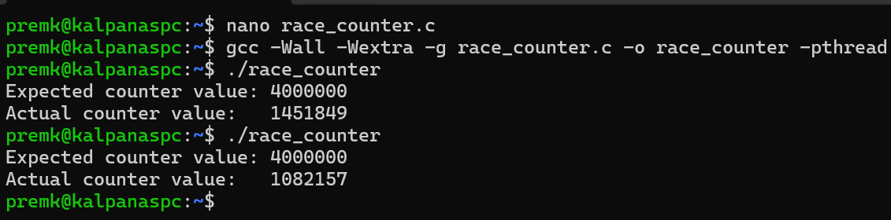
4. Explanation of pthread_create()
The function:
pthread_create(&threads[i], NULL, increment_counter, NULL);
creates a new thread.
Its basic syntax is:
pthread_create(thread, attributes, start_routine, argument);
In our program:
Argument | Meaning
&threads[i] | Stores the thread ID
NULL | Default thread attributes
increment_counter | Function executed by the thread
NULL | No argument passed to the function
The thread begins execution at:
void *increment_counter(void *arg)
5. Explanation of pthread_join()
After creating all threads, the main thread executes:
pthread_join(threads[i], NULL);
This causes the main thread to wait until the specified thread terminates.
Without pthread_join(), the main thread could finish and terminate the process before all worker threads complete.
6. Why Does the Race Condition Occur?
The statement:
counter++;
is not guaranteed to be an indivisible operation.
Conceptually:
counter++;
↓
LOAD counter
↓
ADD 1
↓
STORE counter
Suppose:
counter = 100
Two threads execute concurrently:
Thread 1 Thread 2
-------- --------
LOAD 100 LOAD 100
ADD 1 ADD 1
STORE 101 STORE 101
Expected:
102
Actual:
101
One increment has been lost.
7. Correct Version Using a Mutex
A mutex (mutual exclusion lock) allows only one thread at a time to execute the critical section.
safe_counter.c
#include <stdio.h>
#include <stdlib7h>
#include <pthread.h>
#define NUM_THREADS 4
#define INCREMENTS 1000000
long long counter = 0;
/* Mutex */
pthread_mutex_t lock = PTHREAD_MUTEX_INITIALIZER;
void *increment_counter(void *arg)
{
(void)arg;
for (long long i = 0; i < INCREMENTS; i++)
{
pthread_mutex_lock(&lock);
counter++;
pthread_mutex_unlock(&lock);
}
return NULL;
}
int main(void)
{
pthread_t threads[NUM_THREADS];
for (int i = 0; i < NUM_THREADS; i++)
{
if (pthread_create(&threads[i], NULL, increment_counter, NULL) != 0)
{
perror("pthread_create");
exit(EXIT_FAILURE);
}
}
for (int i = 0; i < NUM_THREADS; i++)
{
if (pthread_join(threads[i], NULL) != 0)
{
perror("pthread_join");
exit(EXIT_FAILURE);
}
}
printf("Expected counter value: %lld\n", (long long)NUM_THREADS * INCREMENTS);
printf("Actual counter value: %lld\n", counter);
pthread_mutex_destroy(&lock);
return 0;
}
Compile:
gcc -Wall -Wextra -g safe_counter.c -o safe_counter -pthread
Run:
./safe_counter
Expected output:
Expected counter value: 4000000
Actual counter value: 4000000
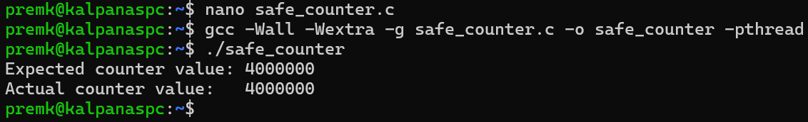
8. Critical Section
The following code is the critical section:
pthread_mutex_lock(&lock);
counter++;

pthread_mutex_unlock(&lock);
Only one thread can execute this section at a time.
Thread 1 → LOCK → counter++ → UNLOCK
↑
Thread 2 ─────── waits ──┘

Thread 2 → LOCK → counter++ → UNLOCK
Thus, the shared variable is protected from concurrent modification.
9. Race Condition vs Mutex
Feature | Without Mutex | With Mutex
Shared counter | Yes | Yes
Multiple threads | Yes | Yes
Synchronization | No | Yes
Race condition | Possible | Prevented for this critical section
Result | May be incorrect | Expected result
Performance | Potentially faster | Lock/unlock overhead
Data consistency | Not guaranteed | Protected

Experiment: Synchronizing a Multithreaded Counter Using Mutex Locks
Aim
To modify the multithreaded counter program by using POSIX mutex locks and compare its output and performance with the race-condition version.
Objectives
- Protect a shared variable using pthread_mutex_lock() and pthread_mutex_unlock().
- Compare synchronized and unsynchronized counter results.
- Analyze how synchronization affects correctness and execution time.
- Understand the trade-off between data consistency and synchronization overhead.
1. Race-Condition Version
In the previous program, multiple threads directly execute:
counter++;
on the shared variable.
The expected value is:
NUM_THREADS × INCREMENTS
= 4 × 1,000,000
= 4,000,000
But because counter++ involves a read-modify-write sequence, concurrent execution can result in lost updates.
Possible output:
Expected counter value: 4000000
Actual counter value: 2876431
The exact incorrect value can change between executions.
2. Mutex-Synchronized Version
A mutex (mutual exclusion) ensures that only one thread at a time enters the critical section.
mutex_counter.c
#include <stdio.h>
#include <stdlib.h>
#include <pthread.h>
#include <time.h>
#define NUM_THREADS 4
#define INCREMENTS 1000000
/* Shared variable */
long long counter = 0;

/* Mutex */
pthread_mutex_t lock = PTHREAD_MUTEX_INITIALIZER;
/* Thread function */
void *increment_counter(void *arg)
{
(void)arg;
for (long long i = 0; i < INCREMENTS; i++)
{
pthread_mutex_lock(&lock);
counter++;
pthread_mutex_unlock(&lock);
}
return NULL;
}
int main(void)
{
pthread_t threads[NUM_THREADS];
clock_t start, end;
start = clock();
/* Create threads */
for (int i = 0; i < NUM_THREADS; i++)
{
if (pthread_create(&threads[i],
NULL,
increment_counter,
NULL) != 0)
{
perror("pthread_create");
exit(EXIT_FAILURE);
}
}
/* Wait for all threads */
for (int i = 0; i < NUM_THREADS; i++)
{
if (pthread_join(threads[i], NULL) != 0)
{
perror("pthread_join");
exit(EXIT_FAILURE);
}
}
end = clock();
printf("Expected counter value: %lld\n", (long long)NUM_THREADS * INCREMENTS);
printf("Actual counter value: %lld\n", counter);
printf("Execution time: %.6f seconds\n", (double)(end - start) / CLOCKS_PER_SEC);
pthread_mutex_destroy(&lock);
return 0;
}
3. Compile
Compile the synchronized version:
gcc -Wall -Wextra -O2 -pthread mutex_counter.c -o mutex_counter
Run:
./mutex_counter
Typical output:
Expected counter value: 4000000
Actual counter value: 4000000
Execution time: 0.18 seconds
The exact execution time depends on the system.
